Kol Simcha Torah Gazette
For parshas bamidbar 5786
Vol 10 Issue 31 (Whole #496) 29 Iyar 5786/ May 16, 2026
Printed L’illuy nishmas Nechama bas R’ Noach, a”h
For a free subscription, please forward your request to keren18@juno.com
Past emails can be found on the website ShabbosStories.com under Brooklyn Torah Gazette

JUST ONE SHABBOS:
President Trump Urges Jewish Americans To Observe Shabbos In Honor
Of America’s 250th Anniversary

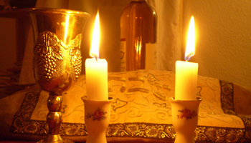

President Donald Trump issued a proclamation on Monday, May 4th designating May 2026 as Jewish American Heritage Month and called on Americans of all backgrounds to observe Shabbos from sundown May 15 to nightfall May 16 – Shabbos Parshas Bamidbar – in honor of the nation’s 250th anniversary.
The proclamation ties Jewish American contributions to American independence and frames Shabbos observance as part of the broader “Rededicate 250” national jubilee.
“Jewish Americans are encouraged to observe a national Sabbath,” Trump wrote in the proclamation. “From sundown on May 15 to nightfall on May 16, friends, families, and communities of all backgrounds may come together in gratitude for our great Nation.”
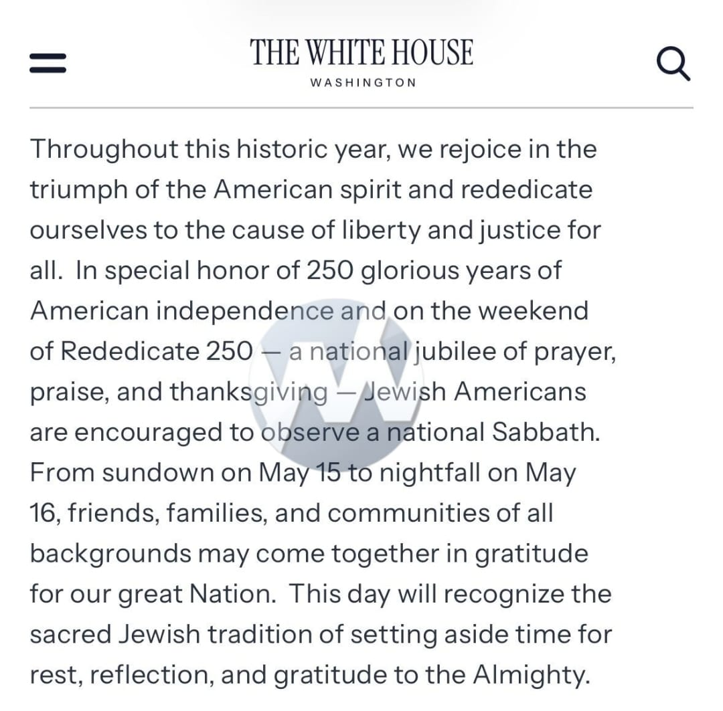
Trump cited President George Washington’s 1790 letter to the Hebrew Congregation in Newport, Rhode Island, in which Washington pledged that the United States “gives to bigotry no sanction, to persecution no assistance.” Trump invoked the historical language to frame his administration’s approach to combating antisemitism.
“Under my leadership, we are aggressively fighting the violence against Jewish Americans that increased under my predecessor, prosecuting hateful criminals to the fullest extent of the law, and working to end the scourge of anti-Semitism throughout our institutions, especially on college campuses,” Trump stated.
The proclamation highlighted Haym Salomon, an early American financier and Revolutionary War supporter, as emblematic of Jewish American contributions to the nation’s founding. Trump described Salomon as “instrumental in the success of our Continental Congress and Founding Fathers” and noted that he continued his work for independence even after being imprisoned by the British.
Trump framed religious freedom as central to American identity. “As President, I will never stop fighting to protect our birthright of religious freedom — a sacred right that continues to guide our Nation, drawing us closer to the Almighty each and every day,” he wrote.
The proclamation calls on Americans to “celebrate the heritage and contributions of Jewish Americans” throughout May and to “observe this month with appropriate programs, activities, and ceremonies.”

Reprinted from the May 5, 2026 website of Yeshiva World.

Why Did G-d Need to Give the Commandment to Moshe to Count the Number of Jews in the Desert?
From the Teachings of the Lubavitcher Rebbe
Rabbi Menachem Mendel Schneerson, Zt”l

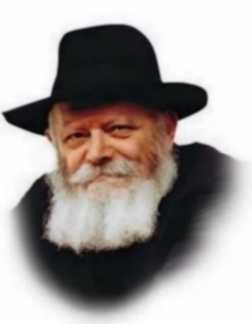
The fourth book of the Torah, Bamidbar, which literally means "in the wilderness," is known as the Book of Numbers. This is because the very first commandment recorded there is that of conducting a census of the Jewish people in the desert.
The Biblical commentator Rashi explains that G-d surely knew how many Jews there were without needing to count them. But, He gave the commandment to show His great love for the Jewish people.
How does counting express love? On the surface it would appear to imply the opposite. When a census is taken, no distinction is made between a simple person and a great one. A person's innate qualities and characteristics are totally ignored, each individual being equal in the count. The mighty and the humble are both counted as one.
Yet, it is with the very act of counting that the concept of love is expressed. When a census is conducted, one does not consider the talents and qualities of the people being counted. Rather, what is considered is the innate, essential quality that is common to all of them. Each Jew is worth precisely one because, from the point of view of the essential quality, every Jew is exactly equal to another.
How do we measure our fellow man? We can judge him according to his talents and abilities, his likes and dislikes, his social standing, or his economic situation. According to these standards people are genuinely different from one another, and each person is characterized by the circumstances in which he finds himself. But these characteristics are only temporary. The rich man will lose his standing if he loses his wealth, and the wise man will be forgotten if there is no further need for his knowledge.
But if we judge our fellow man not according to these external criteria, but rather by that essential common quality which classifies him as a "person" - then there is no difference between one and the other. Each of us has the very same traits to the same degree.
Now we can begin to understand how the mitzva (command) to count the Jews showed the love G-d has for them. We might err, and think that G-d only loves the Jews because of their personality traits, or because they accepted His Torah, or because of their good deeds. If that were so, G-d's love for the Jews would be limited and dependent upon these traits. What would happen if the Jews ceased to carry out the will of G-d? Would G-d stop loving them?
When G-d gave the commandment to count the Jews, He was emphasizing that His relationship with them is not based on external qualities. It is based on the fact that each person has this essential Jewish quality which is present and equal in all of us. It is as if G-d were saying: "From My standpoint, I love all of you equally, and there is absolutely no difference between you, even between the righteous and the sinner. I love each of you to the same degree, as I love that inner Jewish quality which each of you possesses to the same degree."
This concept further serves to prepare us, through unity and love of our fellow Jew, for the giving of the Torah on Shavuot. This week's Torah portion of Bamidbar reminds us of the true worth of each Jew and the equality of each member of the Jewish Nation.

Reprinted from the Parshat Bamidbar email of L’Chaim, a publication of the Lubavitch Youth Organization in Brooklyn, NY. Adapted from the works of the Lubavitcher Rebbe
Rav Avigdor Miller on
Praying for a Million Dollars
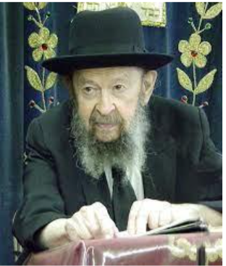

QUESTION: Is there anything wrong with me davening to Hashem that He should give me a million dollars?
ANSWER: It depends what you’ll do with a million dollars. Ordinarily it’s a nuisance to have a million dollars. Once you get a million dollars then your life is no longer a life. You’re a slave to your money. You have to take care of your property. You have no menuchah. A poor man goes to sleep at night and nobody bothers him. A rich man is always on the go. If you want a million dollars in order to build a big yeshivah, then pray for a million dollars, yes. If that’s what you want it for, absolutely.
If you pray for other things, it’s surely good. הרחב פיך means you should open your mouth wide and ask for everything. Who says only a million dollars is good? Open your mouth and say, “Ribono Shel Olam, help me know a whole mesichta. I would love to know Bava Kama from the beginning to the end.” Wouldn’t that be a glorious thing to know Bava Kama? And maybe Bava Metzia too? Maybe Bava Basra too? Do you know what a happiness it would be if you knew three mesichtas from the beginning to the end? You’re a real millionaire. Nobody could compare to you.
So first pray for one perek. Ask Hashem that He should help you to know one perek perfectly. Then you’ll know another perek and another one and little by little maybe you’ll become a millionaire in Torah.
You should pray to have good children too. Make sure to pray for everything. And if you pray for a million dollars too, it’s no cheit. Only you have to know that in case it happens it’s not such a simple matter. You have to expect a great deal of complications.
(June 1995)

Reprinted from a recent email of Toras Avigdor. (Transcribed from a classic Thursday night hashkafah lecture delivered by Rav Avigdor Miller in June, 1996 – Tape #E-147.)

Thoughts that Count
for Our Parsha

And G-d spoke to Moses in the wilderness of Sinai... (Num. 1:1)
G-d purposely chose a desert in which to give the Torah. He spoke to the Jews in a place where everyone enjoyed free access, to show us that every Jew has an equal obligation and share in the Torah. (Bamidbar Rabba and Michilta B'Shalach)

Count the heads of the congregation of the children of Israel, by their families, by their fathers' houses... (Num. 1:2)
In order to know the number of people in each tribe, first they were counted according to their families and then each member of the family was counted. This shows us the importance of the family. The existence of the Jewish people is based on and dependant on the actions of each family. (The Lubavitcher Rebbe)

Count (literally, "Raise") the heads of the congregation... (Num. 1:2).
When Moses was commanded to arrange a census of the Jewish people, the word used was "se-oo" more literally meaning "raise." This indicates that the counting was actually an elevation for the Jews. The census brought about the resting of the Divine presence on the Jewish nation because it indicated that each individual could affect the destiny of the entire people. Similarly, Maimonides writes: "Each person should consider the entire world as balanced between good and evil deeds. His one action could sway the world to the side of good, bringing salvation to the whole world." (Shaloh)
Those who pitch [their tents] on the east are the standard of the camp of Judah...the tribe of Issachar...and the tribe of Zevulun...(Num. 2:3-7)
The tribes of Judah, Issachar and Zevulun camped near Moses and Aaron. For this reason, they all became great scholars. This shows us the importance of choosing righteous neighbors. (Rabbeinu Bechaye)
"Each person to his flag with signs for the house of their ancestors" (2:2).
Every individual must ask himself, "When will my deeds reach the level of those of my ancestors?" Our goal should be that our ancestors' achievements will act as a "signpost" for our own actions. (Sefat Emet)

Reprinted from the Parshat Behar and Parshat Bechukosai 5763/2003 editions of L’Chaim, a publication of the Lubavitch Youth Organization in Brooklyn, NY.

The Last Twins: The Man Who
Saved 80 Boys from Mengele
By Susan Hornik

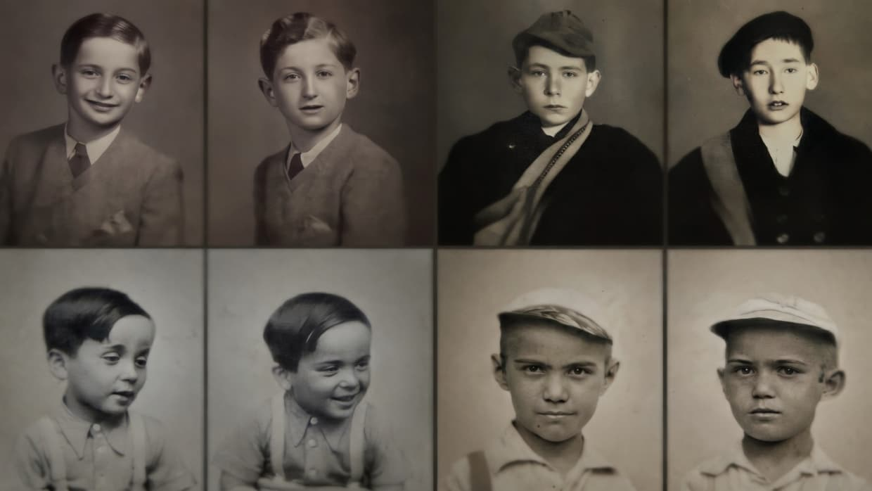

At Auschwitz, a 29-year-old Hungarian Jew named Erno "Zvi" Spiegel risked his life daily to protect boys from Josef Mengele. His story is finally being told.
Josef Mengele [yemach shemo] gave Erno "Zvi" Spiegel two choices: cooperate with his experiments on boy twins, or die. Spiegel chose survival — and used it to save as many boys as he could.
In 1944, Spiegel was a 29-year-old Hungarian Jewish prisoner at Auschwitz-Birkenau. He survived the gas chambers for a single reason: he was a twin. Nazi doctor Josef Mengele spared twins for his brutal experiments, giving Spiegel something rare in that dark place — a chance to act.
Mengele put him in charge of about 80 boy twins, forcing him to translate for the Nazis and document the details of the brutal procedures. Spiegel couldn't stop them from happening, but he tried to keep the boys alive in any way possible, becoming a father figure to them.
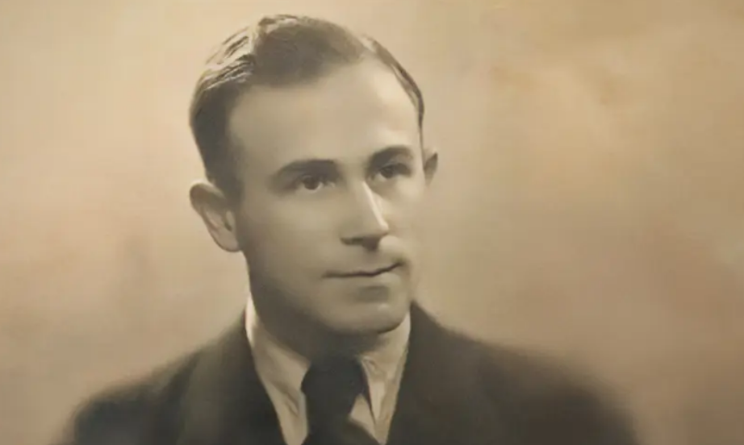
Erno Spiegel

After liberation, the boys begged Spiegel not to leave them, so he walked them all out of Auschwitz, braving a frigid winter and the mayhem of wartime Europe to bring them home to Hungary.
His story is the subject of a fascinating PBS documentary, "The Last Twins," narrated by actor Liev Schreiber.

A Daughter's Love
For many years, Spiegel did not speak in detail about what occurred during the war.
"I grew up knowing fragments — I had only very basic information," said his daughter, Dr. Judith Richter, an executive producer on the film. "I knew that my father had been a twin in Auschwitz, that he had a number, and that his sister had been there with him — but beyond that, there was very little detail. It was not something he spoke about at length."
Still, there were a few facts that lingered with her.
"I knew he was liberated on January 27th by the Russian army. And I knew that exactly one year later, on that same date, he got married. That juxtaposition — between liberation and the beginning of a new life — always felt deeply symbolic, even before I fully understood the story behind it. Only much later did I begin to grasp the depth of what happened to him, and the choices he had made during that time."
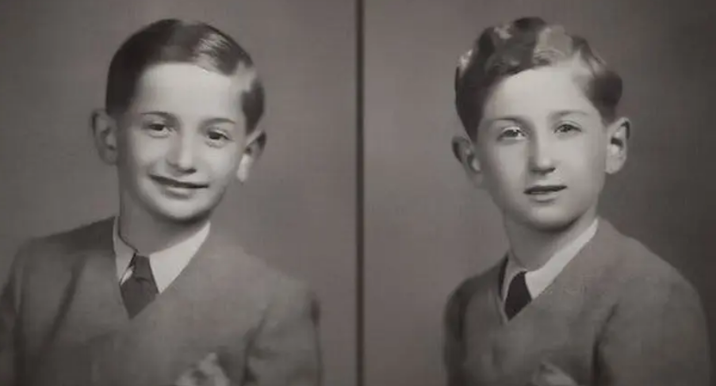
Twins Gvorgy and Istvan Kun who were saved by Spiegel

Richter hopes viewers will be inspired to make a difference in the world after seeing her father's story.
"The film is about the impact of choices, and holding on to humanity, even in the darkest circumstances. I hope people understand that every action matters — that they matter. You don't need power or position to do something meaningful. My father had none, yet he chose to act. He tried to protect the children, he would give them lessons in geography or math, creating moments of normalcy in an impossible reality. He also insisted on calling them by their names, not by the numbers they were assigned in the camp. These were simple acts, but they were his way of preserving their dignity."

Finding Out the Truth
Richter discovered the full truth decades later, by chance, while reading a story on Mengele in LIFE magazine. That propelled her to launch a years-long journey to uncover his past.
"Over time, I began to understand that what he had done was not only extraordinary, but also deeply relevant to how we think about moral choice and responsibility."
Because of that LIFE article, Spiegel was able to reconnect with many of the Holocaust survivors he had helped, a few of whom are featured in the documentary.
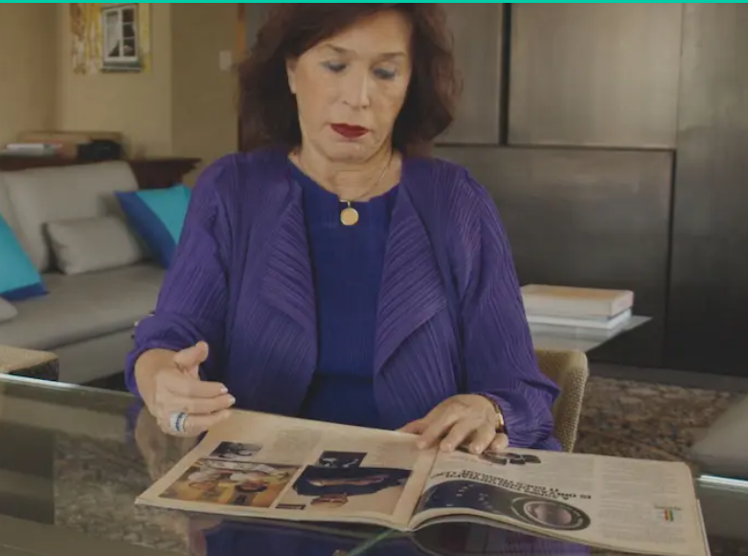
Dr. Judith Richter

"Meeting the men my father helped save was one of the most meaningful and emotional parts of this journey," said Richter. "They had gone on to build full lives — families, careers, entire worlds — and there was a quiet but powerful awareness that my father had been part of that chain of survival."
Finding them was a gradual and, in many ways, organic process. Some were identified through testimonies and archival records at Yad Vashem (Israel's Holocaust memorial and archive). From there, one connection led to another, as people shared names, memories, and relationships that helped piece the story together.
Richter first met a group in 1985, following a mock trial at Yad Vashem.
"And from that moment, the circle continued to expand. Not everyone I met is included in the film. Some of those who shared their stories with me over the years are no longer alive. Their absence is deeply felt, but their voices remain an essential part of the story we set out to preserve."
The decision to make the film came from Richter's sense that her father's life should not remain private.
"It is not only a family story — it is a human story. At a time when the number of survivors who can tell their stories firsthand is rapidly diminishing, there is an urgency to preserve and share accounts that speak not only to what happened, but to how individuals chose to act within it." [Erno Spiegel died in Israel in 1993 at the age of 78.]
"The Last Twins" premieres on PBS on Monday, June 15th.

Reprinted from the current website of aish.com

What You Need to Know About Blessings Before Eating
By Yehuda Shurpin

Before eating or drinking, Jewish law requires us to pause and recite a blessing.¹ This isn't merely a polite “thank you” to the Almighty; our Sages teach that enjoying the pleasures of this world without first saying a blessing is akin to benefiting from something that belongs to the Temple — something consecrated and not yours to take. Everything in this world ultimately belongs to G-d: “The earth and all that it contains are G-d’s.”² The blessing is our way of acknowledging that, and in doing so, we receive — so to speak — Divine permission to partake.³
While this article will focus more on the general laws of blessings said before eating, and less on which blessings to say over different foods, let’s run through the basics in order to have a better understanding of the laws in general and what is done if, for example, you say the wrong blessing.

The Basic Framework: One Food, One Blessing
The Sages established a system of blessings organized by category, so that the blessing we recite reflects the nature of the food itself. Here’s the basic breakdown of the different blessings.⁴
Bread (Hamotzi): Bread made from any of the five grains (wheat, barley, spelt, oat, and rye) is considered the most significant of all foods. When eating a proper bread meal, one recites Hamotzi lechem min ha’aretz — “Who brings forth bread from the earth.” This is the premier blessing of the table and includes all other foods eaten within the same meal.


Art by Sefira Lightstone

Other grain-based foods (Mezonot): Foods made from the five grains that are not actual bread (such as cake, crackers, pasta, or cereal) receive the blessing of Borei minei mezonot, which acknowledges G-d as the One who sustains us with nourishment.
Wine and grape juice (Hagafen): Wine occupies a special place in Jewish life. Due to its unique importance in ritual and celebration, the Sages gave it its own distinct blessing: Borei pri Hagafen — “Who creates the fruit of the vine.”
Tree fruits (Ha’etz): Fruits that grow on trees (apples, oranges, almonds, and the like) receive the blessing of Borei pri ha’etz, “Who creates the fruit of the tree.”
Vegetables and produce from the ground (Ha’adama): Foods that grow from the ground but not on a tree (vegetables, legumes, berries, bananas, and similar items) receive Borei pri ha’adama, “Who creates the fruit of the ground.”
Everything else (Shehakol): For foods that don't fall into any of the above categories — meat, fish, eggs, dairy, water, juice (other than grape juice), candy, etc. — one recites Shehakol nih’yeh bidvaro, “All came into being through His word.” This is a broad blessing that gives praise for all of creation.
For more on the different blessings, see Brachot: Blessings for Food & Other Occasions.
These categories form the framework for determining the proper blessing, though the classification of specific foods can be more complex.
It’s also important to note that although some of these blessings seem more general, and may technically include some of the other types of foods—for example, fruit from a tree also technically grows from the ground—nevertheless, our Sages saw the wisdom of blessing G-d in a more specific way, and thus introduced the individual blessings for each category (we will get to the halachic ramifications of this further on).
Proper Attire When Saying a Blessing
Preferably, out of respect for G-d’s name, you should be properly dressed when reciting the blessing over food. That said, you can technically recite the blessing even if not fully attired, following these guidelines:
Women: At minimum, you need to make sure your private parts are covered, so, for example, wearing a bathing suit takes care of that. If you’re in a sauna or otherwise unclothed, this can be accomplished by simply sitting down.⁵
Men: In addition to making sure your private area is covered,⁶ there must be a “separation” between your heart and your nether region. Bathing trunks normally take care of both considerations. If not, you can press a towel against your body.⁷ If your body is covered by water, you may place your hands against your body (i.e., folding your arms) to make this separation.⁸
Additionally, a male may not recite a blessing (or anything with G-d’s name) without some sort of head covering. In a pinch, you can have someone cover your head with their hand, but your own hand does not suffice (even though covering your head with your own hand does suffice if you need to walk somewhere and you don’t have a head covering, as we’re generally careful not to walk four cubits bareheaded).⁹
When and How to Say the Blessing?
One recites a blessing before eating or drinking, no matter how small the amount of food they will be eating.¹⁰
When saying the blessing, one should hold the food upon which the blessing is said (or the spoon or fork containing the food) in the right hand (left-handed people should hold it in their left hand) and only then say the blessing. If you did not hold the food but it was in front of you when you said the blessing, you do not need to say the blessing again.¹¹
When reciting the blessing, one must do so with care and focus, understanding that you are blessing G-d, and aware of the specific food or drink over which you are reciting the blessing. You should not be distracted.¹²
Unsure whether you already made the blessing?
If you're unsure whether you said the blessing or not, you do not repeat the blessing.¹³
No interruption between blessing and eating
You should not speak after reciting the blessing until you have eaten. If you do speak about something unrelated to the meal, you must repeat the blessing, but if what you said is related to the meal—such as asking for the salt—you do not repeat the blessing.¹⁴
Which Foods Are Included With the Blessing?
A single blessing can cover multiple foods of the same type, but this depends mainly on your intent and what is in front of you at the time of the blessing.
If you have in mind to eat additional foods, even if they are not yet in front of you, the original blessing generally covers them. Moreover, if other foods of the same blessing are already in front of you, they are included, even if you do not specifically think about them.¹⁵
If you have neither intent nor additional foods present in front of you, the ruling depends on what is brought later. If it is more of the same food, you generally do not repeat the blessing. If it is a different food that shares the same blessing, a new blessing may be required—especially if you have already finished the first food.¹⁶
Practically, when reciting a blessing, it is best to have in mind that it should cover any similar foods you may later eat. This avoids uncertainty and ensures that one blessing can properly apply to all.
If You Forget To Say a Blessing
Solids: If you begin eating without reciting a blessing, and realize while the food is still in your mouth, the proper response depends on the situation. If the food can be removed without becoming repulsive (such as hard candy), you should take it out, recite the blessing, and then eat it. If removing it would make it repulsive (such as chewed food), you should move it to the side of your mouth and recite the blessing before swallowing.¹⁷
Liquids: If you realize while you’re drinking that you forgot to make a blessing, and you have more of the same drink available, spit it out, say the blessing, and then take more of the same drink.¹⁸ If you’ve already finished the drink, think of the words of the blessing in your mind.¹⁹ Note: In this case, you do not recite an after-blessing, even if you drank a revi’it (with the exception of wine, which follows different rules).²⁰
What If Food Spills or Falls After the Blessing but Before Eating?
If food or drink spills after you recite the blessing but before you taste it, the response depends on what remains. If any amount can still be consumed, you should do so immediately, so the blessing is not in vain.
If nothing remains, but more of the same food or drink is in front of you, the original blessing can still apply—provided you intended to take more at the time of the blessing. If you had no such intention, the blessing is considered in vain, and a new blessing must be recited before taking more.²¹
Whenever a blessing is rendered in vain, you should immediately say “Baruch shem kevod malchuto le’olam va’ed” before reciting a new blessing.²²
If You Said the Wrong Blessing
If you mistakenly recite Ha’adama (produce from the ground) on a food that requires Ha’etz (produce from a tree), you have fulfilled your obligation and do not repeat the blessing.²³ But if you mistakenly recite Ha’etz on a food that requires Ha’adama, you have not fulfilled your obligation, and should say “Baruch shem kevod malchuto le’olam va’ed” and recite the correct blessing.²⁴
If you recite Hagafen on grapes, it is acceptable (after the fact, not preemptively), and no other blessing is needed.²⁵
If you recite Shehakol on any food, it is valid (only after the fact, not when done intentionally) and you do not say another blessing.²⁶
Once you have already fulfilled your obligation by reciting a different blessing—such as accidentally saying Shehakol on cake—you may not then recite the correct blessing. Doing so would be considered a blessing in vain.
If You Don’t Know Which Blessing to Say
You should not treat Shehakol or any other general blessing as a default option for uncertainty. Each food requires its specific blessing, and if you are unsure, you must make an effort to determine the correct one. Ignorance does not permit reciting Shehakol on foods that require a more specific blessing.
Only in cases where it is truly impossible for you to find out the correct blessing, or where the Sages themselves did not reach a definitive ruling, may you rely on a more general blessing such as Shehakol or Ha’adama. Otherwise, if you are in doubt, you should refrain from eating the food in question until the matter is clarified.²⁷
Can I Switch Rooms While Eating?
Moving while eating can determine whether a new blessing is required.
If you leave the room where you began eating and continue in another room, it is generally considered an interruption requiring a new blessing—even if you do not lose focus in the meantime. If, however, you intended to move to another room from the outset, the original blessing continues to apply, even to other foods with the same blessing only eaten in the second location.²⁸
This leniency applies only within the same building. Moving to a different building—or even stepping outside—requires a new blessing, regardless of your original intent.²⁹
An important exception: if you can still see your original place from where you are now, the change of location is not considered an interruption, and no new blessing is needed.³⁰
When eating with others, the rules differ slightly. If at least one person remains in the original place, the group is considered anchored there, and those who return may continue eating without a new blessing. However, if you continue eating in the new location, a new blessing is required.³¹
Finally, foods that require an after-blessing in the place where they were eaten—such as bread—are treated more leniently. Since you are expected to return to your original place, leaving is not viewed as ending the meal, and the original blessing continues to apply when you resume eating, even elsewhere, provided you had already eaten a significant amount.³²
After Eating
After eating at least a kezayit of food (about one ounce) or drinking a revi’it of liquid (about four ounces), you recite a berachah acharonah (after-blessing).
For more on the laws of the after-blessing see Laws of Blessings After Eating.
Footnotes
1. Talmud, Berachot 35a. 2. Psalms 24:1. 3. See for example, Shulchan Aruch Harav, Orach Chaim 167:1. 4. See Shulchan Aruch Harav, ibid. Seder Birkat HaNehenin 1:2. 5. Shulchan Aruch Harav, Orach Chaim 75:2. 6. Shulchan Aruch Harav, Orach Chaim 74:2. 7. Shulchan Aruch Harav, Orach Chaim 74:1.
8. Shulchan Aruch Harav, Orach Chaim 74:3. 9. Shulchan Aruch Harav, Orach Chaim 2:6 (Mahadura Batra). 10. Shulchan Aruch, Orach Chaim 210:1.
11. Seder Birkat HaNehenin 9:4. 12. Seder Birkat HaNehenin 9:3. 13. Shulchan Aruch, Orach Chaim 209:3. 14. Shulchan Aruch Harav, ibid; Seder Birkat HaNehenin 9:1-2. 15. Seder Birkat HaNehenin 9:5. 16. Seder Birkat HaNehenin 9:5. 17. Shulchan Aruch, Orach Chaim 172:2. 18. Shulchan Aruch, Orach Chaim 172:1. 19. See Mishnah Berurah 172:5; Ketzot Hashulchan 55:9 based on Shulchan Aruch Harav, 185. This is unlike others who rule that in this case you should swallow what's in your mouth and then say the blessing (i.e., since you remembered when it was still in your mouth, but were simply unable to actually say the blessing, it’s still somewhat considered “making the blessing before eating”). In this situation, this blessing also serves as an after-blessing. The only exception to this rule is wine. See Shulchan Aruch, Orach Chaim 172:2 and Magen Avraham ad loc. 20. See previous footnote. 21. Seder Birkat HaNehenin 9:8-9. 22. Seder Birkat HaNehenin 9:10. 23. Seder Birkat HaNehenin 1:4. 24. Seder Birkat HaNehenin 1:4. 25. Seder Birkat HaNehenin 1:16. 26. Seder Birkas HaNehenin 1:4. 27. Seder Birkat HaNehenin 1:5. 28. Seder Birkat HaNehenin 9:11. 29. Seder Birkat HaNehenin 9:11. 30. Seder Birkat HaNehenin 9:12. 31. Seder Birkat HaNehenin 9:13. 32. Seder BirkastHaNehenin 9:14.

Reprinted from the current website of Chabad.Org

